2026 Follow the Label

Shareable Content: E-Newsletter Copy

DATES APPLICABLE: May 15, 2026 – September 15, 2026
SUBJECT LINE: Follow the label, protect your investment
PREHEADER: Stick to the rate, timing and PHI
Email Copy:
Your on-farm decisions play a key role in keeping markets open. Before you spray, Keep it Clean reminds growers, applicators and crop advisors to always read and follow the crop protection label to ensure:
Rate: Always follow the correct application rate.
Timing: Apply crop protection products only at the recommended crop stage.
Pre-harvest interval (PHI): Stick to the product’s PHI – the number of days between spraying and swathing or straight cutting the crop.
Improper or off-label use of pesticides is illegal and may result in unacceptable product residues, putting market access at risk. Protect your investment and help maintain Canada’s world-class reputation as a trusted supplier of canola, cereals and pulses.
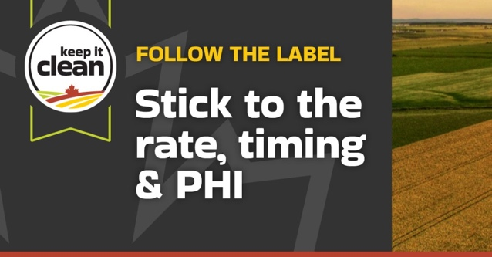
{CTA BOX} Learn More https://keepitclean.ca/5-tips/label/?utm_source=x&utm_medium=organic-image&utm_campaign=25kic5855&utm_id=always-on&utm_term=follow-the-label-canada&utm_content=newsletter-sharing-brief

