2026 Product Advisory

Shareable Content: E-Newsletter Copy

DATES APPLICABLE: April 7 onwards
SUBJECT LINE: 2026 Product Advisory Now Available
EMAIL PRE-HEADER: Keep crops market ready with Keep it Clean’s 2026 Product Advisory
Headline: Keep crops market ready with Keep it Clean's 2026 Product Advisory.
EMAIL COPY:
Keep it Clean’s 2026 Product Advisory is now available to inform growers and crop advisors about the key changes to export market requirements. The Product Advisory outlines the product and crop combinations that may pose market risk for the upcoming growing season.
With 90 per cent of Canadian canola, 80 per cent of Canadian wheat, barley and oats, and 85 per cent of Canadian pulse production being exported annually, the Product Advisory is a vital tool growers can use to ensure their grain meets global agricultural export standards.
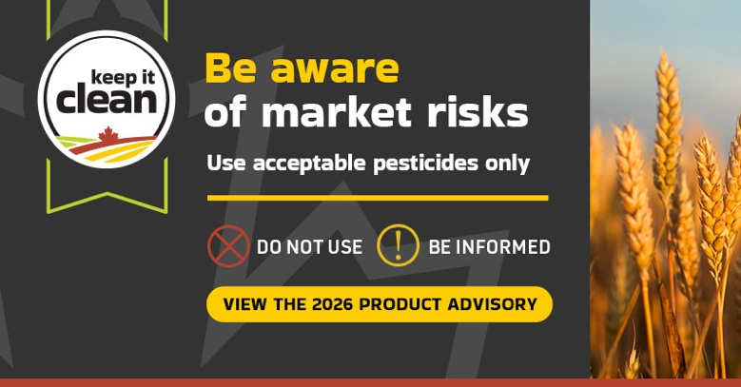
[CTA BOX] Learn more https://keepitclean.ca/tools-resources/product-advisory/?utm_source=x&utm_medium=organic-image&utm_campaign=25kic5855&utm_id=always-on&utm_term=product-advisory-canada&utm_content=newsletter-sharing-brief

