2026 Product Advisory Webinar

Shareable Content: E-Newsletter Copy

  - WEBINAR REGISTRATION
DATES APPLICABLE: April 1st Onwards
SUBJECT LINE: 2026 Product Advisory Webinar
EMAIL PREHEADER: Learn how you can help keep markets open for all
Headline: Keep it Clean is inviting you to attend our upcoming 2026 Product Advisory webinar.
EMAIL COPY:
DATE: Thursday, May 7, 2026
TIME: 11:00 a.m. - 12:00 p.m. CDT
The Keep it Clean Product Advisory informs Canadian growers of potential market risks associated with the use of certain crop protection products on some crops.
Join the experts to learn more about the updated 2026 Product Advisory:
- Krista Zuzak, Director, Crop Protection and Production, Cereals Canada
- Jeff English, Vice President, Public Affairs, Pulse Canada
- Curtis Rempel, Vice President, Innovation, Production and Supply, Canola Council of Canada
Keep it Clean recommends growers always consult their grain buyers before applying any crop protection products on the Product Advisory to keep their crops market ready throughout the growing season.

CEU credits are available for CCAs.
[CTA BOX] Register Now https://thinkshift.zoom.us/webinar/register/1017733319847/WN_AVKRPUBWRJWjRhUYe2X58A

  - ENEWSLETTER CONTENT – WEBINAR REMINDER
DATES APPLICABLE: April 1st Onwards
SUBJECT LINE: Don’t Forget to Register for the 2026 Product Advisory Webinar
EMAIL PRE-HEADER: Valuable tips and insights on growing market-ready crops
EMAIL COPY:
Headline: Have you registered for the 2026 Product Advisory webinar?
Keep it Clean is hosting a Product Advisory Webinar on May 7 at 11:00 a.m. CDT.
The 2026 Keep it Clean Product Advisory has important updates you need to know about before the growing season begins.
During the webinar, our experts will review the key changes to export market requirements. We'll discuss the updated product and crop combinations that may pose market risks for 2026 growing season.
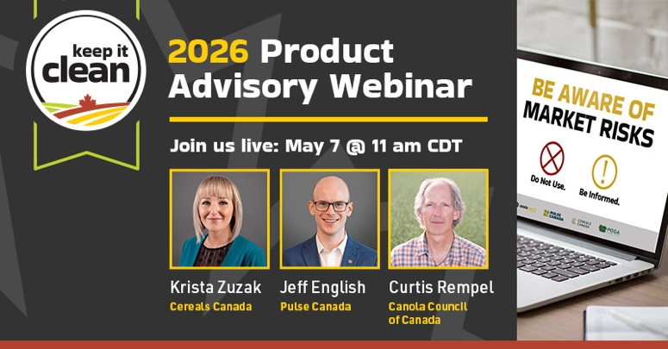
The webinar is open to growers, crop advisors and other value chain stakeholders who want to learn more about the potential market risks before making crop protection application decisions this upcoming season.
Don't miss this opportunity to stay ahead of changing maximum residue limits (MRLs) and protect market access for your crops.
CEU credits are available for CCAs.
[CTA BOX] Register Now https://thinkshift.zoom.us/webinar/register/8017733320117/WN_AVKRPUBWRJWjRhUYe2X58A

