Desiccants Shareable Content:

E-Newsletter Copy

DATES APPLICABLE: July 2 – September 15
Subject Line: Use only registered desiccants on cereal crops
Headline: Protect market access for wheat, barley and oats.
Email Copy:
Protect market access when using desiccants
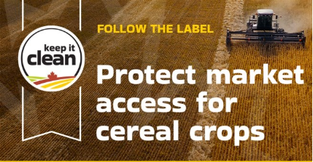
Keep it Clean reminds growers that using only registered desiccants on wheat, barley and oats is essential to protecting market access for Canadian grain.
If applying desiccants to cereal crops, using a product not registered for your crop type is an off-label use. It can also increase your risk of trade disruption as residues produced may not be covered by maximum residue limits (MRLs) in export markets. In some cases, MRLs may be absent or set at very low levels, increasing the risk of shipment rejection.
It is important to distinguish between products registered for desiccation and those registered for pre-harvest weed control. Products such as diquat and glufosinate-ammonium are not registered for use on wheat, barley or oats. Glyphosate is not a desiccant and must only be applied according to label directions.
Following label rates and pre-harvest intervals help ensure acceptable levels of residues on grain entering the supply chain. Following the label helps safeguard the quality and reputation of Canadian cereals.
Visit KeepItClean.ca for more information on registered desiccants and best management practices.
{CTA BOX} Learn More https://keepitclean.ca/5-tips/label/desiccants/?utm_source=x&utm_medium=organic-image&utm_campaign=25kic5855&utm_id=always-on&utm_term=desiccants-canada&utm_content=newsletter-sharing-brief

