General Message: Social Copy

  - SOCIAL / X (TWITTER POSTS)

Dates applicable: Year-round
Option 1
Keep it Clean has the tips, tools and resources you need to keep your crops market ready. Sign up for our newsletter to get timely updates sent straight to your inbox 👉 https://bit.ly/415IBeo #CdnAg #SustainableCdnAg
Image:


Option 2
Keep it Clean provides timely updates on potential market risks and resources for on-farm practices to help ensure crops meet the standards of domestic and export customers. Sign up for our newsletter today 👉 https://bit.ly/4125vmS #CdnAg #SustainableCdnAg
Image:
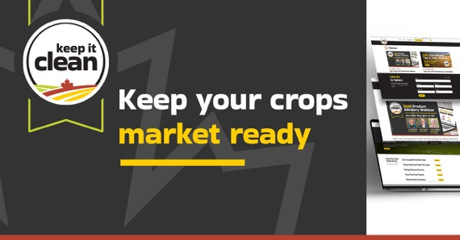

Option 3
How can you keep your crops market ready?
- Use acceptable pesticides only
- Always read and follow the label
- Manage disease pressures
- Store your crop properly
- Deliver what you declare
Learn more 👉 https://bit.ly/4shgkNa #CdnAg #SustainableCdnAg
Image:
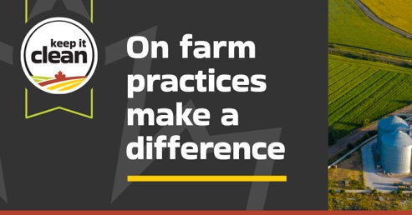

Option 4
Help maintain Canada's reputation as a quality grain supplier. Safeguard the marketability of your crops with Keep it Clean's 5 on-farm tips to grow market-ready crops. Learn more 👉 https://bit.ly/47vBe3A #CdnAg #SustainableCdnAg
Image:


  - Images
The images for the above posts and available for download on the Keep it Clean website: https://keepitclean.ca/tools-resources/share/

