Pre-harvest Glyphosate Shareable Content: E-Newsletter Copy

DATES APPLICABLE: July 2 – September 15
Subject Line: Avoid unacceptable glyphosate residue levels
Headline: Pre-harvest glyphosate staging tips
Email Copy:
Applying pre-harvest glyphosate for weed control too early can result in unacceptable product residues in harvested grain.
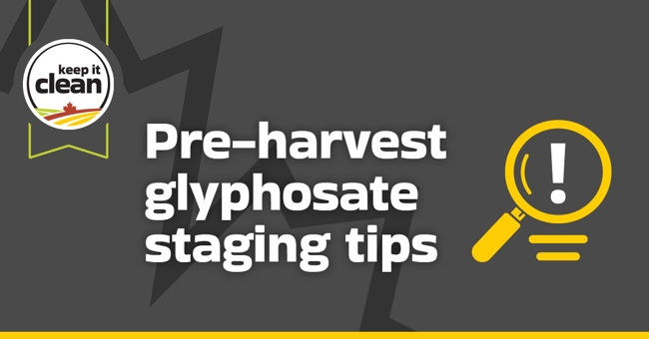
Help protect and preserve market access by following the Keep it Clean Pre-Harvest Glyphosate Staging Guide. You will find visual examples to help determine when grain moisture is less than 30% in your crop.
For canola, by applying at 50-60% seed colour change in the least mature areas of the field, growers can be confident grain moisture will be less than 30%. At this stage, seeds in the main stem will be:
- Top = green, firm to roll
- Middle = mostly brown, with some speckling
- Bottom = completely brown-black
Follow these best practices to manage the pre-harvest application of glyphosate for canola, cereals and pulses:
- Where allowed, glyphosate is registered for pre-harvest weed control and is not to be used as a desiccant.
- Pre-harvest glyphosate may only be applied when grain moisture content is less than 30% in the least mature part of the field, including any areas of regrowth which may produce seed. Applying glyphosate too early can result in unacceptable product residues in the grain.
- To avoid unacceptable residue levels, always follow the product’s label for application rate, timing and pre-harvest interval (PHI).
- Never harvest earlier than recommended – this can increase the risk of unacceptable glyphosate residues in harvested grain.
- When using glyphosate for pre-harvest weed control in a tank mix with other products, such as saflufenacil (Heat), the products must still be applied when grain moisture content is less than 30% in the least mature part of the field and must also follow the PHI of the most restrictive product label.
{CTA BOX} Learn More https://keepitclean.ca/tools-resources/pre-harvest-glyphosate-staging-guide/?utm_source=x&utm_medium=organic-image&utm_campaign=25kic5855&utm_id=always-on&utm_term=follow-the-label-canada&utm_content=newsletter-sharing-brief

