Pre-harvest Glyphosate Shareable Content: Social Copy

  - SOCIAL / X (TWITTER POSTS) – GENERAL MESSAGE
The following messages and images can be used throughout the season from June 17, 2026 – September 15, 2026

Version 1:
Where allowed, glyphosate is registered for pre-harvest weed control and is not to be used as a desiccant. To avoid unacceptable residues, only apply when the grain moisture content is less than 30% in the least mature part of the field. Learn more #CdnAg #SustainableCdnAg 👉 https://bit.ly/3NBPeBY
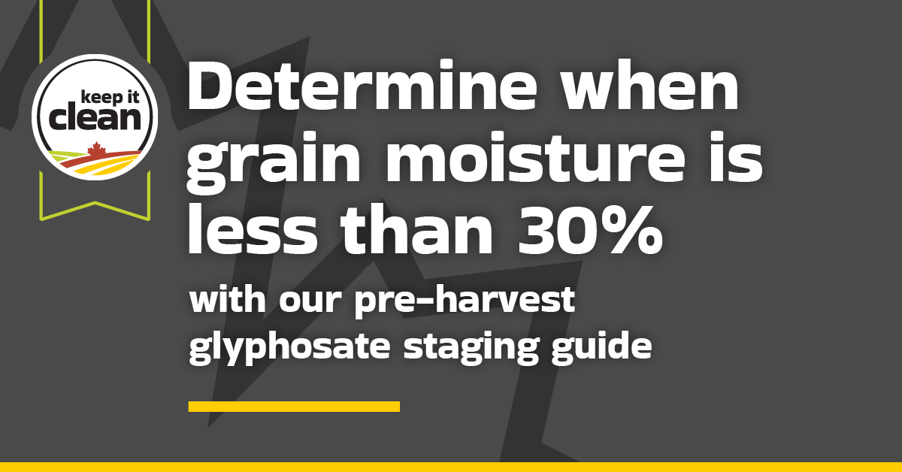

Version 2:
Applying pre-harvest glyphosate for weed control too early can result in unacceptable residues. Use our staging guide to help assess when your crops are ready for spraying. Learn more #CdnAg #SustainableCdnAg 👉https://bit.ly/4cTNXAu
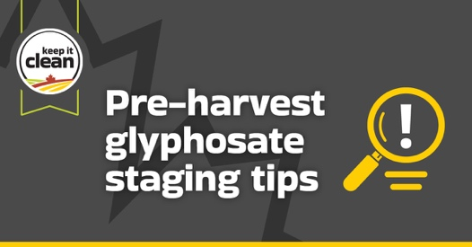

  - SOCIAL / X (TWITTER POSTS) – CEREALS SPECIFIC MESSAGE
The following messages and images can be used during the dates indicated: July 2 – September 15
Version 1:
Remember, cereals treated with pre-harvest glyphosate may not be accepted. Check out our pre-harvest staging guide and follow the label to avoid unacceptable product residues. #CdnAg #SustainableCdnAg 👉 https://bit.ly/47d0pHW
Version 2:
The thumbnail test can help you determine if a crop is ready for pre-harvest glyphosate application. Use our staging guide to determine when grain moisture is less than 30% in cereal crops. #CdnAg #SustainableCdnAg 👉 https://bit.ly/40IV3k4
The following image can be used for both X posts:
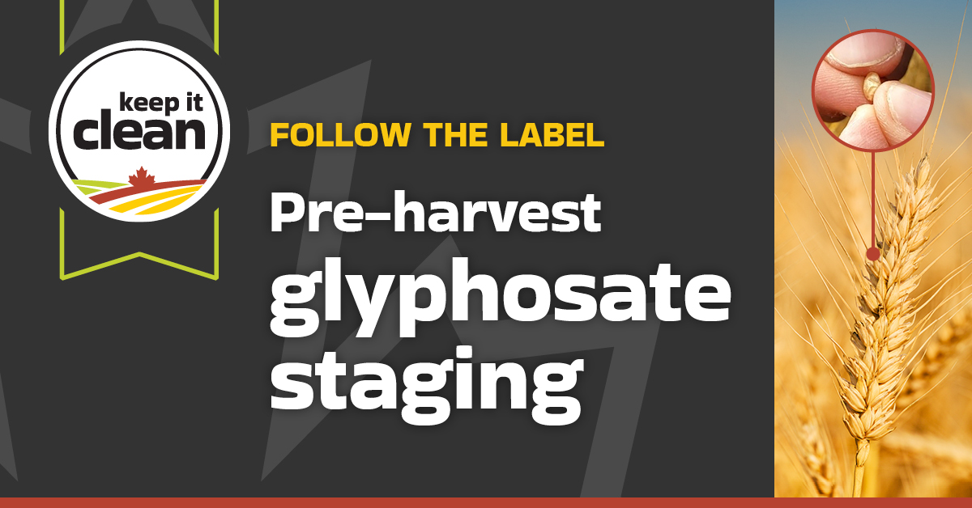

  - SOCIAL / X (TWITTER POSTS) – CANOLA SPECIFIC MESSAGE
The following messages and images can be used during the dates indicated: July 2 – September 15
Version 1:
Know how to identify when your canola is at the right stage for pre-harvest glyphosate application. Always follow the label and check out our pre-harvest staging guide for visual examples. #CdnAg #SustainableCdnAg 👉 https://bit.ly/4sZiaCV
Version 2
Pre-harvest glyphosate may only be applied when grain moisture is <30%. For canola, this means waiting until 50-60% seed colour change in the least mature areas of the field. Know what to look for with our pre-harvest staging guide. #CdnAg #SustainableCdnAg 👉 https://bit.ly/4t1lGgf
The following image can be used for both X posts:
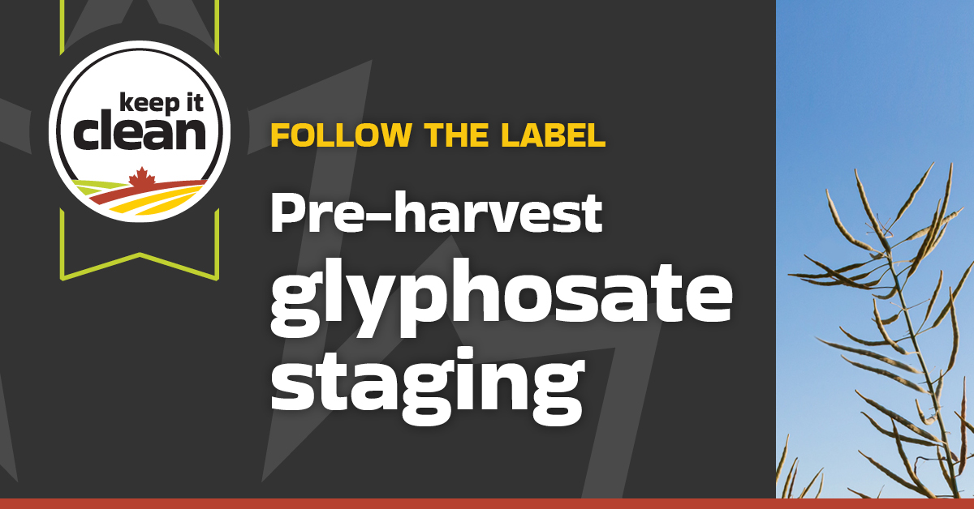

  - SOCIAL / X (TWITTER POSTS) – PULSE SPECIFIC MESSAGE
The following messages and images can be used during the dates indicated: July 2 – September 15
Version 1:
Unacceptable pre-harvest glyphosate residues pose a market risk for all. Learn how to determine when grain moisture is less than 30% in your pulses with the help of our staging guide. #CdnAg #SustainableCdnAg 👉 https://bit.ly/4bpq4zK
Version 2:
Use our pre-harvest glyphosate staging guide to determine when grain moisture is less than 30% in your pulse crops. Follow the label and check with your grain buyer before applying pre-harvest glyphosate to protect market access. #CdnAg #SustainableCdnAg 👉 https://bit.ly/3NFzTjE
The following images can be used for both X posts:

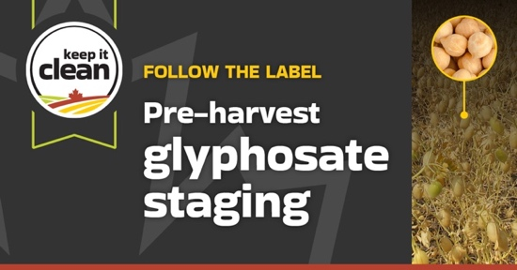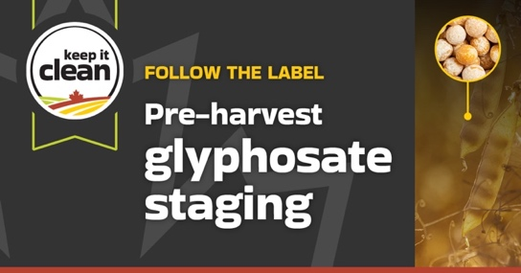
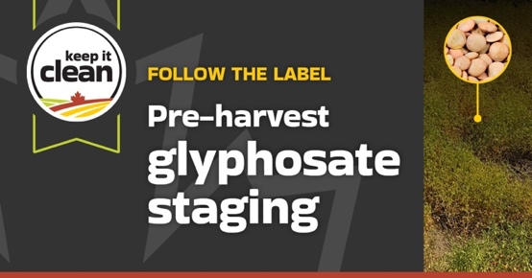

The image options for social posts are also available for download in the resources section of the Keep it Clean website: https://keepitclean.ca/tools-resources/share/

