  - Store Your Crop Properly – Malathion Shareable Content: E-Newsletter Copy

NEWSLETTER CONTENT – VERSION 1
DATES APPLICABLE: June 1 – July 31
SUBJECT LINE: Tips to keep your canola ready for market
EMAIL HEADLINE: Keep canola bins malathion-free
EMAIL COPY:
Treating bins with malathion now makes them unsuitable for storage of canola this growing season. Malathion can linger in bins for months and the residue can be picked up by canola seed, making it unacceptable for export.
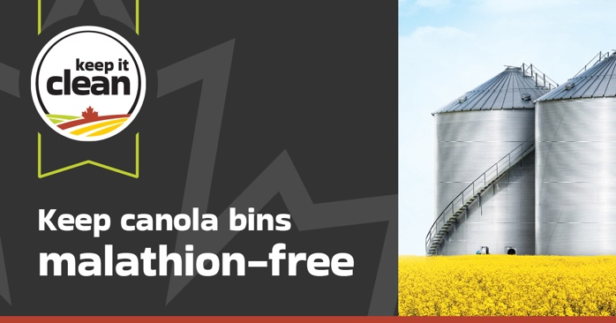
You can help protect and preserve Canada’s reputation as a trusted supplier of high-quality canola and reduce the risk of contaminating your harvest by planning storage requirements accordingly. Never use malathion to prepare canola for storage or treat bins in which you plan to store canola this growing season.
Get more information on how to keep your crops ready for market and protect your investment.
CTA BOX: Learn More https://keepitclean.ca/5-tips/storage/malathion-canola-bins/?utm_source=x&utm_medium=organic-image&utm_campaign=25kic5855&utm_id=always-on&utm_term=malathion-canada&utm_content=newsletter-sharing-brief

NEWSLETTER CONTENT – VERSION 2
DATES APPLICABLE: August 1 – September 30
SUBJECT LINE: Storage tips to keep your canola ready for market
EMAIL HEADLINE: Bins treated with malathion should not be used for canola storage
EMAIL COPY:
Keep it Clean is reminding canola growers that any bin that has been treated with malathion this growing season should not be used for canola storage this fall. Malathion residue can linger in bins for months after treatment and can be transferred from the bin to canola seed, putting marketability at risk.
Canola found with malathion residues is unacceptable for export customers and can damage Canada’s reputation as a trusted supplier of high-quality canola. Before storing your canola, make sure the bin was not treated with malathion this growing season.
Follow these other storage procedures to protect the quality of your crop:
- Clean bins thoroughly prior to storing your crop.
- Only use approved bin treatments (e.g. diatomaceous earth) prior to storing canola.
- Condition crops to moisture and temperature levels safe for long-term storage.
- Keep bins cool, dry and well-ventilated and check their condition regularly.
- Make sure your storage bins are free of treated seed and animal protein like blood meal and bone meal.
Get more information on how to keep your crops ready for market and protect your investment.
CTA BOX: Learn More https://keepitclean.ca/5-tips/storage/malathion-canola-bins/?utm_source=x&utm_medium=organic-image&utm_campaign=25kic5855&utm_id=always-on&utm_term=malathion-canada&utm_content=newsletter-sharing-brief

IMAGES:
The following images can also be downloaded from the Shareable Content and Graphics section of the website: https://keepitclean.ca/tools-resources/share/
