  - Blackleg Scouting Shareable Content:
  - E-Newsletter Copy

NEWSLETTER CONTENT
DATES APPLICABLE: July 15 – August 31
SUBJECT LINE: Before you harvest, Scout for blackleg
EMAIL HEADLINE: Keep your crops market ready
EMAIL COPY:
Keep it Clean reminds Canadian canola growers that blackleg can cause yield and quality losses, impact profitability and may create a market risk.

To help manage the disease and maintain the effectiveness of varieties’ genetic resistance, growers are encouraged to employ an integrated blackleg management strategy, including pre-harvest scouting for the disease.

Although symptoms of blackleg appear throughout the season, the optimal time to scout for the disease is just before swathing or around 60% seed colour change.

To scout for blackleg, pull up at least 50 plants in a W-pattern through the field and clip at the base of the stem/top of the root to look for blackened tissue. Any black discoloration seen in the cross section can be compared to the disease severity scale (below). The scale rates plants from 0 (no discoloration) to 5 (completely discoloured), and with each step on the rating scale there is a reduction in yield. Stem piece samples can be sent to testing labs to identify blackleg races present in the field.

Visit KeepItClean.ca for scouting tips, videos and tools to assess disease severity and yield loss.

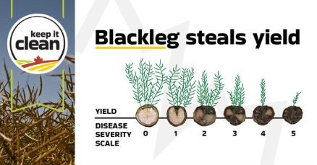

{CTA BOX} Learn More: https://keepitclean.ca/5-tips/disease/blackleg-canola/?utm_source=x&utm_medium=organic-image&utm_campaign=25kic5855&utm_id=always-on&utm_term=blackleg-canada&utm_content=sharing-brief-newsletter-utm

