  - Blackleg Seed Selection Shareable Content: E-Newsletter Copy

NEWSLETTER CONTENT
DATES APPLICABLE: September 1 – December 15
SUBJECT LINE: Blackleg management starts with seed selection
EMAIL HEADLINE: Keep your crops market ready
EMAIL COPY:
Keep it Clean reminds Canadian canola growers that blackleg can cause yield and quality losses, impact profitability and may create a market risk.

To help manage the disease and maintain the effectiveness of varieties’ genetic resistance, growers are encouraged to employ an integrated blackleg management strategy, including growing and rotating resistant varieties.

Plant canola varieties rated R (resistant) and rotate varieties to bring a mix of blackleg resistance genes and sources to the field over time. Use a blackleg race identification test to determine predominant races in the field and help match appropriate major gene resistance.

Visit keepitclean.ca for more tips, videos and tools to help manage blackleg.

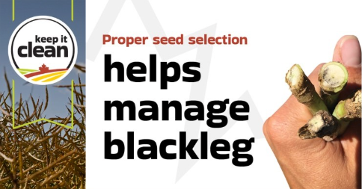

{CTA BOX} Learn More: https://keepitclean.ca/5-tips/disease/blackleg-canola/?utm_source=x&utm_medium=organic-image&utm_campaign=25kic5855&utm_id=always-on&utm_term=blackleg-canada&utm_content=sharing-brief-newsletter-utm

