  - Ergot Management in Cereals
  - Shareable Content: E-Newsletter Copy

NEWSLETTER CONTENT – VERSION 1
DATES APPLICABLE: July 1 – August 1
SUBJECT LINE: Help keep your cereals market ready
EMAIL HEADLINE: Reduce ergot risk this season
EMAIL COPY:
Ergot is a fungal disease that can infect wheat, barley, oats, durum, rye, and grassy weeds in your fields. While ergot infections don't typically cause major yield losses, this disease poses a serious threat to your grain quality and market access.
To protect the marketability of your cereals, it’s essential to manage ergot early and effectively.
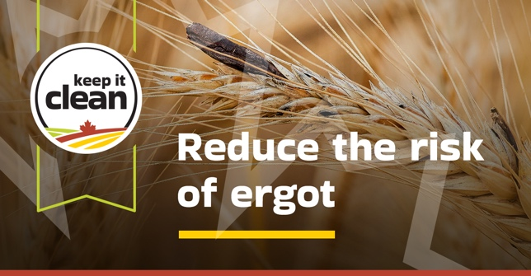
Why it matters:
- Ergot produces toxic alkaloids (mycotoxins) that pose risks to both animal and human health.
- Ergot is a grain grading factor for Canadian cereal grains.
- Even low levels of contamination can lead to rejection of grain shipments and additional cleaning requirements.
Be aware that some export markets for Canadian cereals have established maximum levels for ergot sclerotia and/ or ergot alkaloids in grain.
Timing is critical. Cool, wet conditions during flowering can increase the risk of infection. Monitor your fields and act early to prevent ergot from spreading.
By following best practices, you can reduce contamination and help maintain Canada’s reputation as a trusted supplier of high-quality cereal grains.
Follow the link for ergot management tips and help keep markets open for Canadian cereals:
[Explore Ergot Management Tips] https://keepitclean.ca/5-tips/disease/ergot-management-in-cereals/?utm_source=x&utm_medium=organic-image&utm_campaign=25kic5855&utm_id=always-on&utm_term=ergot-canada&utm_content=newsletter-sharing-brief

IMAGES:
The following image can also be downloaded from the Shareable Content and Graphics section of the website: https://keepitclean.ca/tools-resources/share/

