Blackleg Scouting Shareable Content: Social Copy

  - SOCIAL / X (TWITTER POSTS)

The following messages and images can be used throughout the season from July 15 – August 31

Version 1:
Blackleg in canola can cause yield and quality losses, impact profitability and may create a market risk. Pre-harvest scouting is the best time to check the effectiveness of your blackleg management plan. Learn more👉 https://bit.ly/4co2yCd #SustainableCdnAg #Canola #WestCdnAg

Version 2:
Scouting for blackleg is an important step in your pre-harvest plan to determine the effectiveness of your blackleg management strategy. Check out our tips for scouting and assessing yield loss 👉 https://bit.ly/4sACda2 #CdnAg #SustainableCdnAg #Canola #WestCdnAg

Version 3:
Canola growers, remember to scout for blackleg prior to harvest. This is the best time to determine the effectiveness of your blackleg management practices. Learn more👉 https://bit.ly/3QFLwZ0 #CdnAg #SustainableCdnAg #Canola #WestCdnAg

I
MAGE OPTIONS:
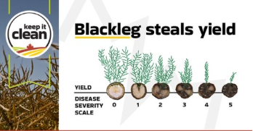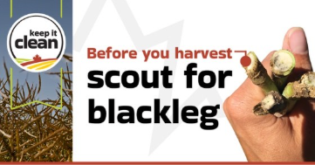
The images in this sharing brief are also available for download in the resources section of the Keep it Clean website: https://keepitclean.ca/tools-resources/share/

