Blackleg Seed Selection Shareable Content: Social Copy

  - SOCIAL / X (TWITTER POSTS)

The following messages and images can be used throughout the season from September 1 – December 15

Version 1:
Plant canola varieties with blackleg resistance that will function in your field. Testing labs can identify blackleg races present in the field and help match appropriate major gene resistance. Learn more 👉 https://bit.ly/4tdSdA1 #SustainableCdnAg #Canola #WestCdnAg

Version 2:
Effective blackleg management starts with seed selection. Choose varieties rated R (resistant) and rotate varieties to bring a mix of resistant genes and sources to the field over time. Learn more 👉 https://bit.ly/3Q4hcr1 #SustainableCdnAg #Canola #WestCdnAg

Version 3:
Where you plant canola is just as important as the varieties you plant. Maintain a break between canola crops to allow blackleg infected residue to decompose — a minimum break of 2 years is recommended. Learn more 👉 https://bit.ly/4cLfGCJ #SustainableCdnAg #Canola #WestCdnAg

IMAGE FOR ALL POSTS:
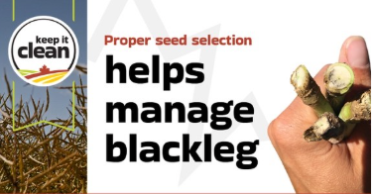

The image in this sharing brief is also available for download in the resources section of the Keep it Clean website: https://keepitclean.ca/tools-resources/share/

