  - Allergens Shareable Content: E-Newsletter Copy

NEWSLETTER CONTENT
DATES APPLICABLE: August 15 – September 30
SUBJECT LINE: Safeguard cereals against allergens
EMAIL PREVIEW: Keep it Clean’s best practices for protecting market access
EMAIL HEADLINE: Tips for safeguarding cereals from allergen contamination
EMAIL COPY:
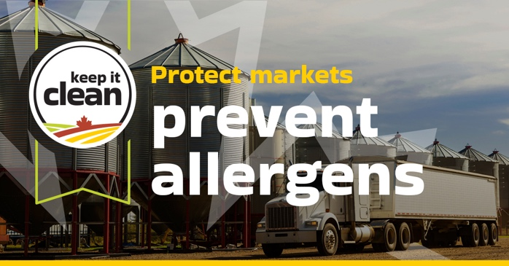
Maintaining Canada’s reputation for clean, safe grain is vital for both domestic and international markets. Even small amounts of allergenic grain mixed with cereals can result in costly rejections or long-term market damage.
Certain crops, like mustard, soy or buckwheat are considered allergens in key export markets. If even trace amounts are present in wheat, barley or oats, they can pose a serious risk to consumer health and market access.
Why it matters:
• Many export markets enforce strict limits on allergenic grain contamination
• Contaminated shipments may be downgraded or rejected entirely
• Allergenic grains can cause severe allergic reactions in some export markets
Learn more about Keep it Clean’s best practices to help safeguard Canada’s grain reputation.
[Explore Allergen Management Tips] https://keepitclean.ca/5-tips/storage/allergens/?utm_source=mailchimp&utm_medium=email&utm_campaign=25kic5855&utm_id=always-on&utm_term=allergens-canada&utm_content=sharing-brief-newsletter-utm

IMAGES:
The following image can also be downloaded from the Shareable Content and Graphics section of the website: https://keepitclean.ca/tools-resources/share/

