  - Storage Risks – Cereals
  - Shareable Content: E-Newsletter Copy

NEWSLETTER CONTENT
DATES APPLICABLE: September 15 – December 15
SUBJECT LINE: Protect your grain: prevent Ochratoxin A
EMAIL HEADLINE: Manage on-farm storage to reduce market risk
EMAIL COPY:
Preventing OTA contamination of grain during storage protects your investment and helps keep markets open for all.
Ochratoxin A (OTA) is a potent, naturally occurring mycotoxin that can form on stored cereal grains in high moisture conditions. OTA is produced by Penicillium verrucosum a naturally occurring soil fungus; but, unlike deoxynivalenol (also known as DON or vomitoxin) which is formed by fusarium infections in the field, OTA forms exclusively in storage.
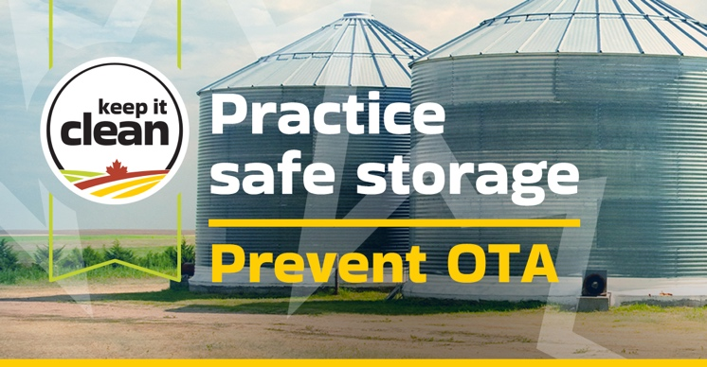
The most common causes of OTA are contaminated soil particles, grain handling equipment, last year’s stored grain, and/or residues remaining in the bin. OTA can develop in small pockets of wet grain, or when water comes in contact with grain.
Why this matters:
- All bins may be at risk, even bins that are generally well managed and properly aerated
- OTA can pose a risk to market access as countries can have different maximum allowable limits of OTA in grain.
- Some countries which import Canadian grain are establishing stricter limits for OTA, making on-farm storage decisions even more critical.
By taking steps to prevent the formation of OTA in stored grain, farmers can protect their investments and help keep markets open for all. No matter the crop that’s in the bin, Keep it Clean recommends checking them frequently and following these best management practices for safe storage:
- Cooling the grain as quickly as possible and keeping it cool
- Keeping bins and grain handling equipment clean
- Thoroughly cleaning dust and debris between grain lots
- Ensuring crops are harvested or dried to a safe moisture level for storage
- Avoid blending tough/damp grain with dry grain on-farm
- Cooling the grain quickly to well below 10°C to achieve uniform, cold temperatures throughout the bulk (ideally well below zero). This can help reduce the production of condensation in storage
- Monitoring bins regularly. Move at least one-third of the grain out of the bin with any detectable temperature rise
- Conditioning the grain as soon as possible in the spring, once ambient temperatures are suitable for drying
By keeping an eye on your bins and taking these steps to maintain the quality of your stored cereal grains, you can protect both its marketability and your investment.
See further information on OTA and how it forms, along with visual examples of OTA formation at critical points of handling and storage.
CTA BOX: Learn More https://keepitclean.ca/5-tips/storage/ochratoxin-a-cereals/?utm_source=mailchimp&utm_medium=email&utm_campaign=25kic5855&utm_id=always-on&utm_term=storage-risks-cereals-canada&utm_content=sharing-brief-newsletter-utm

IMAGES:
The following image can also be downloaded from the Shareable Content and Graphics section of the website: https://keepitclean.ca/tools-resources/share/

