  - De-registered Varieties Shareable Content: E-Newsletter Copy

NEWSLETTER CONTENT
DATES APPLICABLE: February 1 – March 15
SUBJECT LINE: De-registered varieties are a no-grow
EMAIL HEADLINE: Keep it Clean – support the quality and integrity of canola exports
EMAIL COPY:
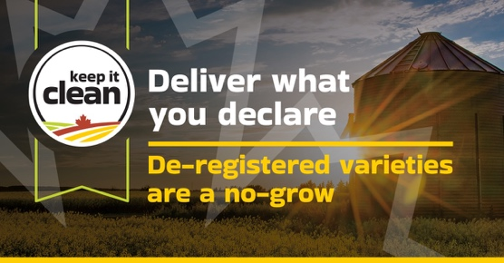
Keeping it clean means considering market access at all points – from seed selection to delivery.
Growing registered canola varieties is an important part of assuring our export customers that the oil and meal quality, biotech traits and disease resistance in our canola supply meets their requirements. To mitigate risk, never seed de-registered varieties or deliver seed produced from them to an elevator or grain handler.
Registered varieties also include agronomic advantages, as de-registered varieties often lack critical disease resistance genetics, such as clubroot resistance.
Let’s all do our part to support the quality and integrity of our canola exports. Working together, we can mitigate risk and help keep markets open for all.
{CTA BOX} Learn More https://keepitclean.ca/5-tips/declare/deregistered-canola-varieties/?utm_source=mailchimp&utm_medium=email&utm_campaign=25kic5855&utm_id=always-on&utm_term=de-registered-v-canada&utm_content=sharing-brief-newsletter-utm

IMAGE:
The following image can also be downloaded from the Shareable Content and Graphics section of the website: https://keepitclean.ca/tools-resources/share/
