  - Deliver What You Declare
  - Shareable Content: Social Copy

X (TWITTER POSTS)
Dates applicable: November - March
Post 1
Keep it Clean wants to remind growers to deliver what you declare to help keep markets open for Canadian grain. Learn more about what it means when you sign the mandatory Declaration of Eligibility for Delivery of Grain 👇 https://bit.ly/4tSzcD9 #SustainableCdnAg
Post 2
When you deliver grain to a licensed grain company in Canada, you must complete a declaration form, confirming the crop you are delivering is an eligible variety (and class, if applicable). Help keep markets open for Canadian grain. Learn more👇 https://bit.ly/4ci2NjB

IMAGES:
The following images can also be downloaded from the Shareable Content and Graphics section of the website: https://keepitclean.ca/tools-resources/share/

CROP AGNOSTIC
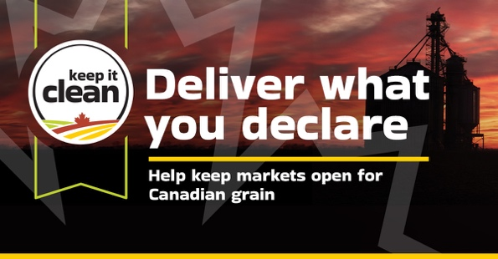

CEREALS
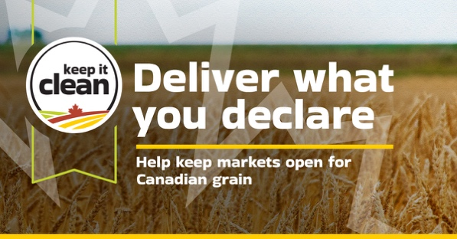

CANOLA
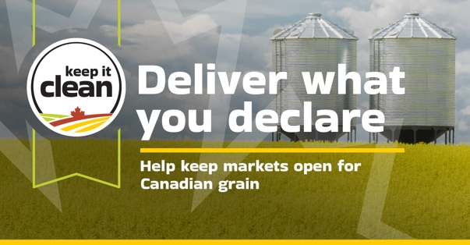

PULSES
