  - Deliver What You Declare
  - Shareable Content: E-Newsletter Copy

NEWSLETTER CONTENT
DATES APPLICABLE: November – March
SUBJECT LINE: Deliver what you declare to help keep markets open
EMAIL HEADLINE: Declare the eligibility of grain at delivery
EMAIL COPY:
Keep it Clean wants to remind growers to deliver what you declare to help keep markets open for Canadian grain.
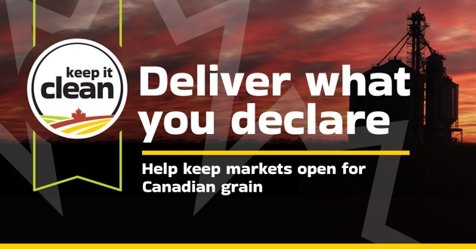
When you deliver to a licensed grain company, you are legally required to complete a Declaration of Eligibility for Delivery of Grain to confirm that the grain you are delivering is of a variety that is eligible for the kind (and class, if applicable) of grain being sold. Your grain buyer may also ask you to sign a commercial declaration that indicates your crop was not treated with specific crop input products to ensure it meets the requirements of our export markets.

Visit KeepItClean.ca for more information on how to safeguard the marketability of your crops.

Learn More https://keepitclean.ca/5-tips/declare/?utm_source=mailchimp&utm_medium=email&utm_campaign=25kic5855&utm_id=always-on&utm_term=dwyd-canada&utm_content=sharing-brief-newsletter-utm

IMAGES:
The following image can also be downloaded from the Shareable Content and Graphics section of the website: https://keepitclean.ca/tools-resources/share/

CROP AGNOSTIC
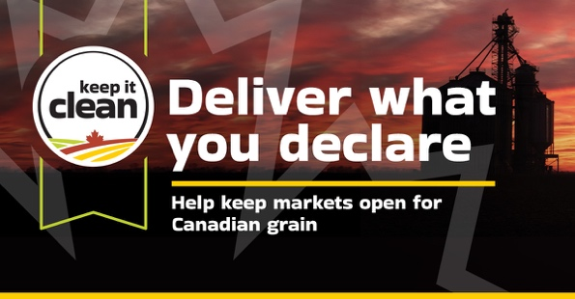

CEREALS
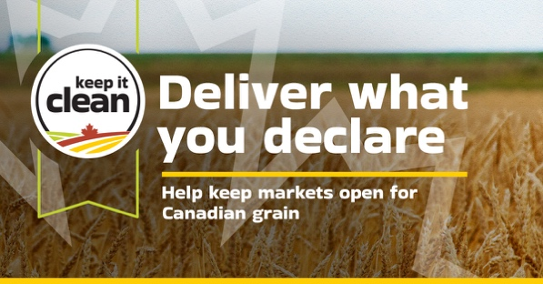

CANOLA
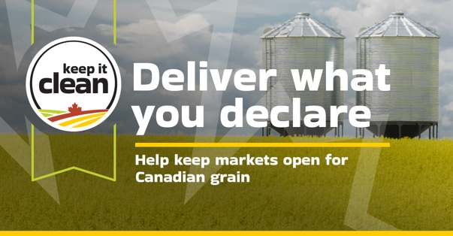

PULSES
