  - Fusarium Seed Selection
  - Shareable Content: E-Newsletter Copy

NEWSLETTER CONTENT
DATES APPLICABLE: November 1 – December 31
SUBJECT LINE – OPTION 1: Prevent fusarium: protect your grain and market access
SUBJECT LINE – OPTION 2: Fusarium may limit crop marketing opportunities
EMAIL HEADLINE: Grow the most FHB-resistant varieties
EMAIL COPY:
Planning for next year’s growing season starts early. Every crop management decision growers make is important and can impact harvest quality and crop marketability – including managing diseases like Fusarium head blight (FHB).
FHB is a serious fungal disease of cereal grains and corn. The cereal grains most affected by FHB are durum wheat, spring wheat, barley and corn. FHB can cause both crop production and market access issues for growers.
FHB affects kernel development, reducing yield and grade. It can also contaminate grain with fungal toxins (mycotoxins) produced in infected kernels. FHB and mycotoxins in harvested grain can negatively impact livestock feed, baking and milling quality of wheat, biofuel (ethanol) production, and malting and brewing qualities of malt barley.
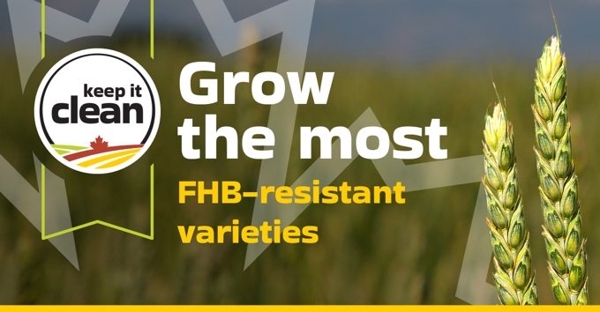

To help keep marketing options open for your harvested grain and maximize your return on investment, Keep it Clean recommends the following best practices to manage FHB during seed selection:

Plan crop rotations to manage fusarium:
- Fusarium can overwinter in crop stubble, so it's important to factor disease management into your plans for next year's growing season. It is crucial that you plan crop rotations that allow adequate time for residues to decompose before returning to cereal crops. Rotate away from cereal crops for at least one — and preferably two or more — years on fields recently infected by FHB.
- Corn is also susceptible to FHB infection, so your crop rotation plan should take this into account if you grow corn.

Grow varieties with the highest FHB-resistance available:
- Growing resistant varieties is one of the most important decisions in managing the disease. The use of resistant varieties is especially important in areas at risk for FHB. Cereals also vary in their susceptibility: durum is the most susceptible to FHB, barley is less susceptible than wheat, and oats are the least susceptible cereal crop.
- Use high quality, vigorous seed and appropriate seeding rates to establish a strong stand.

CTA BOX: Learn More https://keepitclean.ca/5-tips/disease/fusarium-cereals/?utm_source=mailchimp&utm_medium=email&utm_campaign=25kic5855&utm_id=always-on&utm_term=fusarium-canada&utm_content=sharing-brief-newsletter

IMAGES:
The following images can also be downloaded from the Shareable Content and Graphics section of the website: https://keepitclean.ca/tools-resources/share/
